13th Annual
Ray Taylor District Golf Tournament
Pinewood Country Club | September 12, 2019

District Governor Randy Perkins invites you to the Pinewood Country Club to join the Rotary crew on September 12th for food, fun and Rotary Fellowship!

Pinewood Country Club
247 Pinewood Road, Asheboro, NC
Thursday, September 12, 2019
Shotgun start begins at 1:00 pm
$80 per person
Make check out to “District 7690 Golf”
Mail to:
PDG Don Allred
1426 West Lake Drive
Asheboro, NC 27205

2018 Gross Winners – Crescent Rotary Club
Patrick Eakes, Brian Sowers Dupont Kirven, & Jay Harris (not pictured)

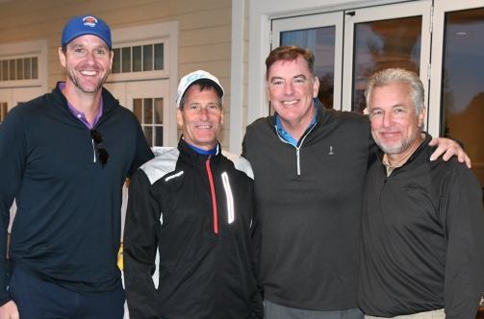
2018 Net Division – Clemons Rotary Club
Mark Witte, Barry Utesch, Rich Spiker and Dan O’Shea
Troy Rotary always leads the way in fashion and team unity.
Tournament namesake, PDG Ray Taylor, with his beloved Betty.

Brothers Breakfast will be sponsoring a hole to “End Polio Now.” You can sponsor one, too. See details on the other side of this page.

You can register at the District Database using the
Calendar Function or return the form below

Thirteenth Annual Ray Taylor District 7690 Golf Tournament
Pinewood Country Club, 247 Pinewood Road, Asheboro, NC
Thursday, September 12, 2019 1:00pm
Deadline for Entries: September 6, 2017
Field Limited to the first 100 golfers

Your name

Your club

Your email address

Your telephone number

Our team would like to participate in (select one) –
- Gross Division: Two of four best ball
- Net Division: Captain’s Choice with handicap

Name/Format | Handicap/Avg Score

- Golf starts at 1:00pm (shotgun start), cookout immediately following golf
- Outing is designed for casual and serious golfers
- Gross Division – two of four best balls each hole
- Net Division – captain’s choice format with handicap applied
- All golfers must be members of the same Rotary Club to be eligible for team awards
- Cost is $80 per person, which includes golf, a cookout after golf, and prizes
- YES I WANT TO HELP STOP POLIO NOW. I’LL BE A HOLE SPONSOR. I’VE ADDED MY $100 TO MY CHECK. I’D LIKE THE HOLE SPONSOR SIGN TO READ (KEEP IT SHORT AND SIMPLE - SEE SAMPLE ON PREVIOUS PAGE):
- Mail to: PDG Don Allred  1426 West Lake Drive Asheboro, NC 27205
For more information contact:
Don Allred: 336-629-1021

