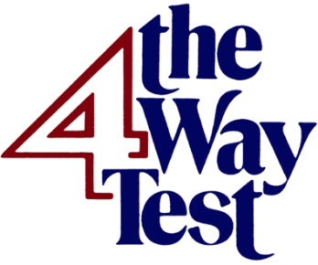 | The Jim Armstrong Four Way Test Speech Contest

To:

From:

Our Rotary Club invites students from your school to participate in the Jim Armstrong Four Way Test Speech Contest. As part of Rotary’s emphasis on supporting our youth, this contest is an opportunity for high school students in grades 9 through 12 to develop their public speaking and leadership skills. If more than one student is interested in participating, our club will select one of the participants to represent it. As there are multiple schools in the area we serve, it is possible that not every school will be represented in the final contest.

As in past years the contest is scheduled to be held the last Saturday in February, February 22, 2025 this year, at the Randolph Community College auditorium in Asheboro, NC.

High school speech contestants are asked to present a six-minute persuasive talk, directed toward their peers, to promote high ethical standards in daily life. The speech should clearly mention the application of Rotary's Four Way Test to facilitate positive and ethical behavior in youth and teens.

What is the Four Way Test? It is a list of four questions Rotarians ask themselves as they consider the ethical situations they face in their life.

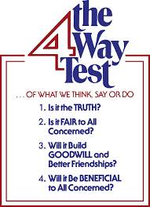

If applicable, they may want to incorporate Rotary’s theme for the current year into their speech.

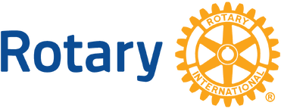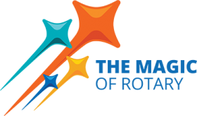
Speeches will be judged for content and presentation. The content should be focused, clear, and accurate, and should be delivered in a logical, organized, and persuasive manner. Articulation, body language, creativity, and effectiveness in engaging peers in the message of ethical choices and behavior relating to the Rotary’s Four-Way Test will be important criteria in judging the presentations.

Prizes will be:
  - $1000 for first place
  - $500 for second place
  - $250 for third place
  - $150 for fourth place
  - $100 for fifth place

At the contest, Rotary District 7690 may videotape the contestants’ presentations and may use them on the Rotary District 7690 website or other Rotary District social media at the District’s discretion.

Additionally, the winner will be invited to present his or her presentation at Rotary District 7690’s Conference, to be held in Cherokee, NC on May 1 – May 5, 2025.

Contest Rules:

- The contest is open to all students in high school grades 9 through 12 who are currently enrolled in a high school curriculum.
- All contestants must be physically present to compete in the contest on February 22, 2025.
- The speeches will be judged for
  - Content (knowledge of subject, logical development, clarity of ideas, persuasiveness to peers).
  - Originality (captures audience interest and attention, effectively connects the information about ethics to the lives of teens today).
  - Delivery (enunciation/pronunciation, expression/poise, sincerity/tone, positive approach)
  - Staying within the 6-minute time limit.
- No props or PowerPoint presentations will be permitted but notes on 3x5 cards are allowed.
- Speeches should be the original work of the contestant and should not be read.
- Contestants should remain anonymous, not revealing their name, town, school, etc. until after the contest to prevent any bias on the part of the judges.
- Each contestant must consent to Rotary District 7690 videotaping their presentation at the District contest on February 22, 2025.

The application form which must be filled out for our club’s representative is attached.

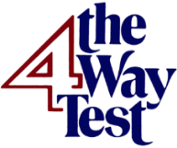 | The Jim Armstrong Four Way Test Speech Contest  Contestant Registration Form  February 22, 2025  Please PRINT all information clearly

Name
Home Address (include city and zip code)

Preferred phone contact number
E-mail Address
High School name and grade
High School Principal Name
High School Principal E-mail
Sponsoring Rotary Club
Rotary Club Contact Name
Rotary Club Contact Phone & e-mail
Emergency Contact Name & Phone

Parent and Student Consent:
I agree to participate in, and to allow my child to participate in, the Rotary Four Way Test Speech Contest as described above, and to abide by all the ground rules set up for the contest.

At various times Rotary District 7690, films, video tapes, and photographs events. It then subsequently publishes or broadcast these materials. If you consent and grant permission for your child’s likeness, work product, or electronic/media to be used/featured by Rotary District 7690, please sign in the appropriate space below.

Consent: I do consent and allow my child to be filmed, videotaped and/or photographed for use by Rotary District 7690 or the media. I also allow my child’s likeness, work product, and electronic/media to be featured by Rotary District 7690.

___________________________________________________________________________________
Child Name (printed)/Signature/Date

___________________________________________________________________________________
Parent/Legal Guardian (circle one) Name(printed)/Signature/Date

Sponsoring Rotary Club Contact:

The Rotary Club of __________________is sponsoring the above candidate for the Four Way Test Speech contest and will be in charge of making sure the candidate complies with the ground rules of the contest and is able to get to the contest safely.

Signature of Club Contact______________________________________________________

